| **Document Field** | **Document Value** |
| --- | --- |
| Title | Responsible Data Science Policy - Parent Procedure (“Procedure”) |
| Document ID |  |
| Version |  |
| Last Updated | [DATE] |
| Last Reviewed | [DATE] |
| Responsible Body | [PARENT PROCEDURE OWNER] |

# 1. Introduction

## 1.1 PURPOSE

This Procedure supports the Organization’s Responsible Data Science Policy (“Policy”) by defining clear processes and documentation to enable execution of the Policy. In particular, this Parent Procedure provides guidance for Personnel to understand which sub-procedure applies to their Project.

# 2. Procedures

Personnel must follow the appropriate sub-procedure for their project or proposed project. The types of possible outcomes are:

* **Not Permitted**: Data Science is not allowed for this type of data or project.
* **Prescriptive Sub-Procedure**: This data or project requires Personnel to follow a prescriptive sub-procedure for review and/or pseudo-anonymization.
* **Adjudicative Sub-Procedure**: This data or project requires Personnel to follow the Adjudicative Sub-Procedure, such as a Risk Committee or Internal Review Board.

The table below provides guidance on how sub-procedures apply to specific use cases. Personnel must use the applicable Sub-Procedure listed below for their project or proposed project.

[[EXAMPLE TABLE]]

| **Order** | **Scope** | **Sub-Procedure** |
| --- | --- | --- |
| 1 | Does the Project Dataset include minors? | Not Permitted |
| 2 | Is the purpose of the Project to target ads? | Advertising (Prescriptive) |
| 3 | Other (any use cases not covered above) | Committee (Adjudicative) |

[[EXAMPLE FLOWCHART]]

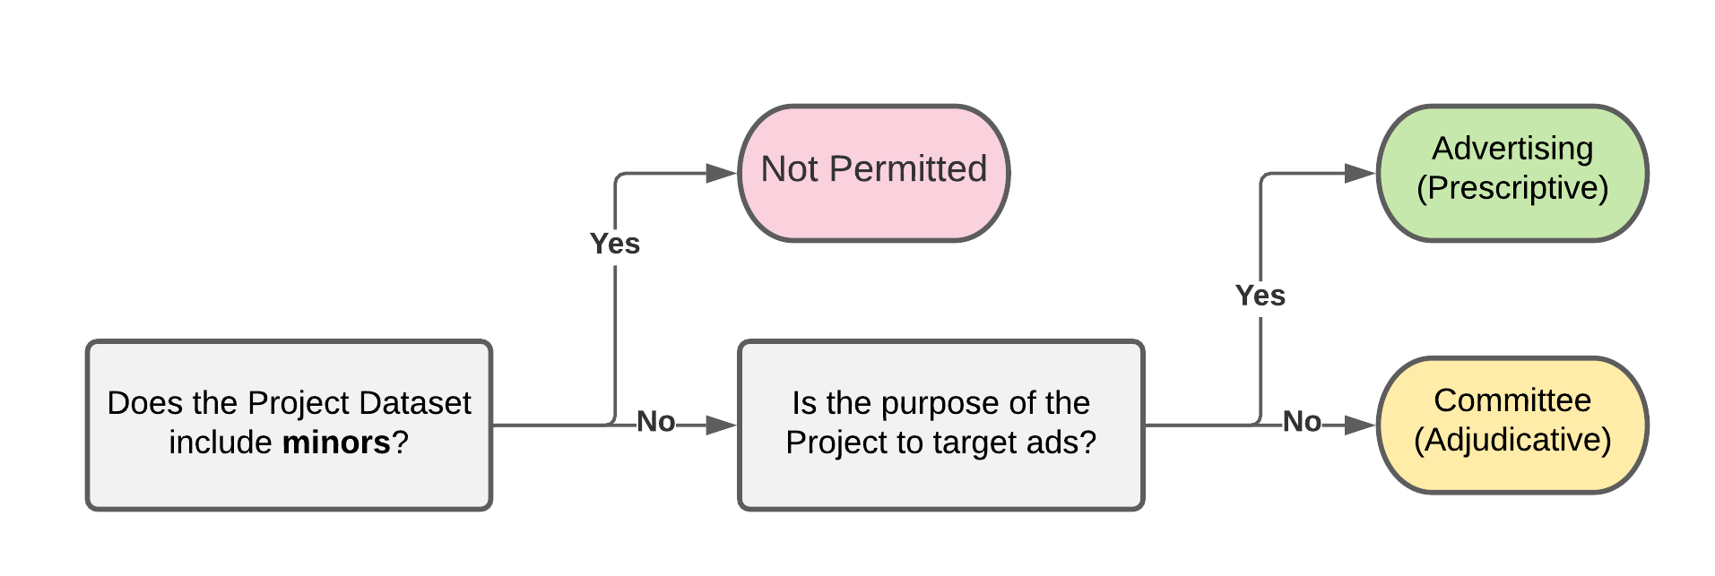

## 2.1 PRESCRIPTIVE SUB-PROCEDURES

Personnel must follow the procedures enumerated in the specific Sub-Procedure referenced above. All Prescriptive Sub-Procedures are located at: [POLICY KNOWLEDGE BASE].

## 2.2 ADJUDICATIVE SUB-PROCEDURES

Personnel must follow the procedures enumerated in the Adjudicative Sub-Procedure, located at: [POLICY KNOWLEDGE BASE].

# 3. Guidance

Personnel with questions about how to follow these procedures should first consult the Organization’s internal resources:

[list relevant resources, such as handbooks, Wiki pages, etc.]

Questions or comments related to this document can be directed to [PARENT PROCEDURE OWNER] at [PARENT PROCEDURE OWNER CONTACT].